Business Plan Example Template
Below are the key business plan headings, sections and sub-sections for the format that is typically found in a professional business plan. Feel free to adapt and customise this template to suit your type of business or industry.
If you run out of time or patience with your plan, and decide that professional help would be of value, then don’t hesitate to contact us at Irish Business Plans. We have over ten years’ experience helping entrepreneurs develop their ideas and prepare professional business plans. We would be delighted to help. Get in touch to find out more.

1. Executive Summary

1.1 Overview / Synopsis of Business Plan

1.2 Keys to Success

1.3 Table of Key Commercial Indicators
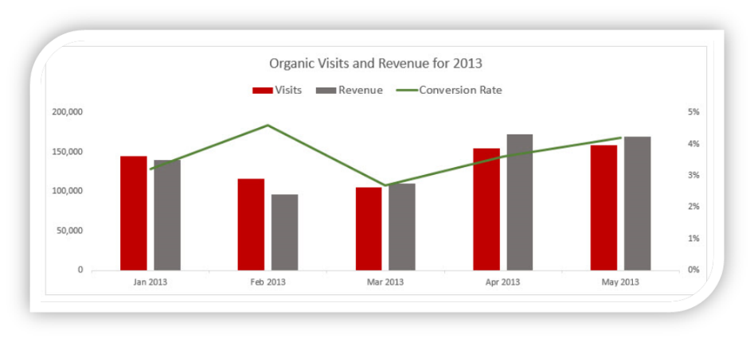

1.4 Overview of Funding Requirements

2. Business / Company Description

2.1 Location or Premises (Offline or Online)

2.2 Legal Structure – Promoters, Shareholders, Board (Insert Table)

2.3 Mission Statement

2.4 Business History and / or Background

2.5 Business Advisors & Partners

2.6 Short Term Objectives – with Timeline

2.7 Long Term Objectives (Strategic) – with Timeline

3. Products and Services

3.1 Market Problem or Opportunity

3.2 Your Solution (Product or Service in Detail)

3.3 Product / Market Demand
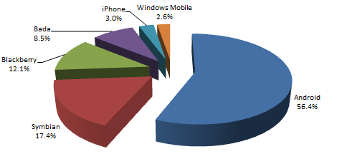

3.4 Key Suppliers

3.5 Future Product or Service Developments

3.6 Trademarks or Patents

4. Industry, Market & Competitor Analysis

4.1 Target Market & Valuation

4.2 Targeted Market Share

4.3 Market Influences – Trends and Growth Rates

4.4 Barriers to Entry

4.5 Competitor Profiles

4.6 Building a Competitive Advantage

4.7. S.W.O.T. Analysis
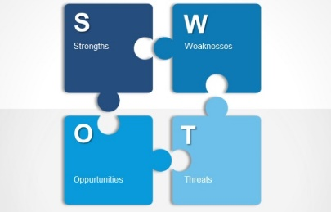

5. Sales

5.1 Sales Forecasts

5.2 Sales Cycle or Model

5.3 Pricing Strategy

5.4 Sales Management Strategy

6. Marketing and Communications

6.1 Goals & Positioning Strategy

6.2 Promotional Tools and Activities

6.3 Timelines and Budgets

7. Research and Development

7.1 Synopsis of R&D to date

7.2 Planned R&D – Product or Service Development

7.3 Copyrights, Brands, Patents

8. Operations – Staffing and Organisation

8.1 Organisational Chart and Management Summary

8.2 Current Staffing Levels

8.3 Payroll Analysis Table

8.4 Future Staffing Levels

9. Financials

9.1 Start Up or Expansions Costs

9.2 Funding

9.3 Notes & Assumptions to the Trading Projections

9.4 Trading & Profit and Loss Projections (Sample Format)
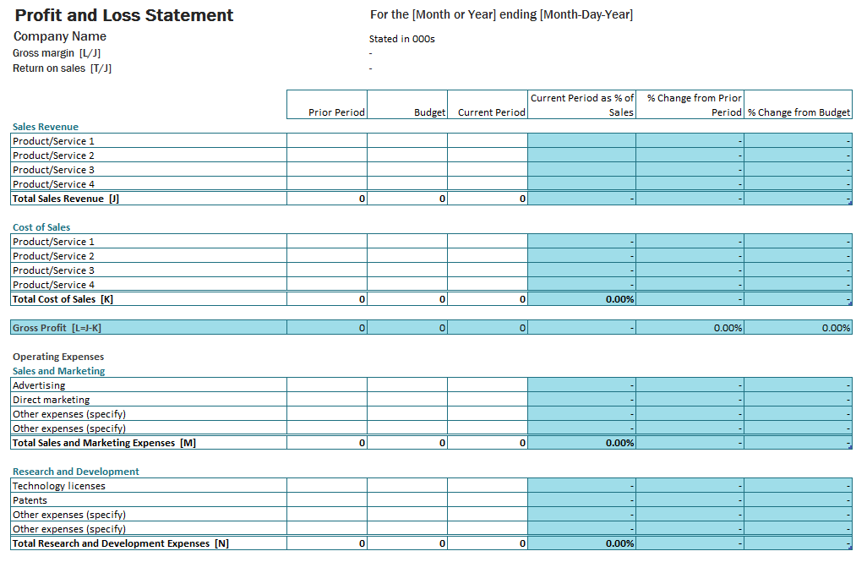

9.5 Cash Flow Projections (Sample Format)
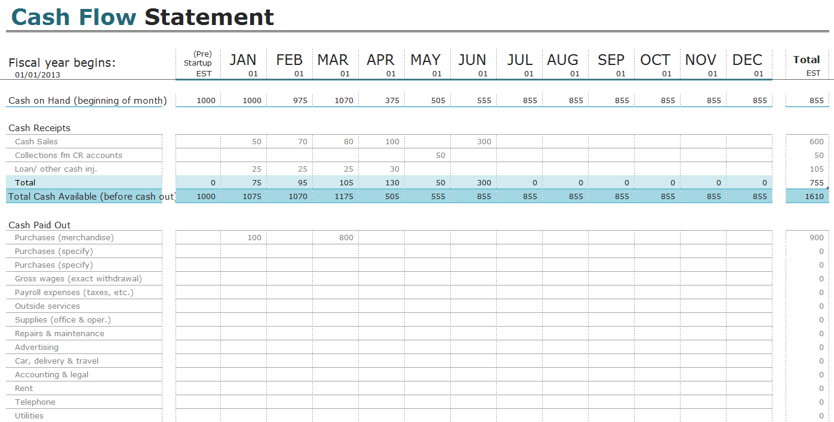

9.6 Balance Sheet Statements
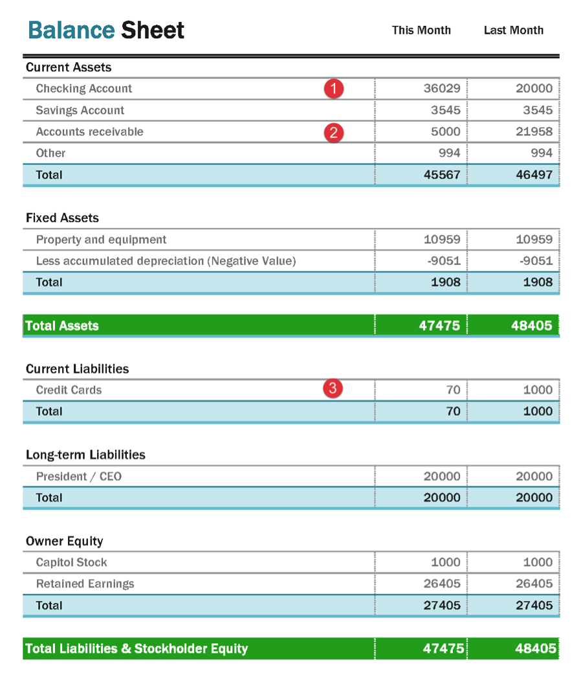

These are the key headings, sections and sub-sections that are typically found in a professional business plan. Feel free to adapt and customise these headings to suit your business.
If you run out of time or patience with your plan, and decide that professional help would be of value, then don’t hesitate to contact us at Irish Business Plans. We have over ten years’ experience helping entrepreneurs develop their ideas and prepare professional business plans. We would be delighted to help. Get in touch to find out more.
W: www.irishbusinessplans.com
E: mark@irishbusinessplans.com
T: +353 (0)85 720 4406

